**October 14, 2024 – The Wind Knows My Name**

**By Isabel Allende**

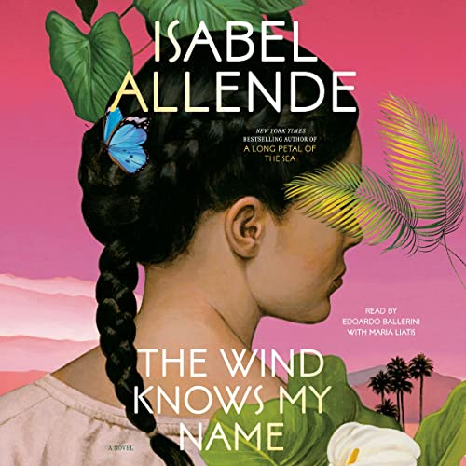**Vienna, 1938.** Samuel Adler is five years old when his father disappears during Kristallnacht—the night his family loses everything. As her child’s safety becomes ever harder to guarantee, Samuel’s mother secures a spot for him on a Kindertransport train out of Nazi-occupied Austria to England. He boards alone, carrying nothing but a change of clothes and his violin.

**Arizona, 2019.** Eight decades later, Anita Díaz and her mother board another train, fleeing looming danger in El Salvador and seeking refuge in the United States. But their arrival coincides with the new family separation policy, and seven-year-old Anita finds herself alone at a camp in Nogales. She escapes her tenuous reality through her trips to Azabahar, a magical world of the imagination. Meanwhile, Selena Durán, a young social worker, enlists the help of a successful lawyer in hopes of tracking down Anita’s mother.

Intertwining past and present, *The Wind Knows My Name* tells the tale of these two unforgettable characters, both in search of family and home. It is both a testament to the sacrifices that parents make and a love letter to the children who survive the most unfathomable dangers—and never stop dreaming.

**ALL ARE WELCOME TO JOIN THE DISCUSSION**

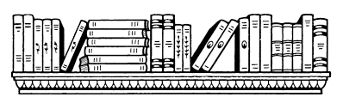

**BEST LIBRARY EVER**

**BOOK CLUB SELECTIONS**

**Faith Church/Calvin Library**

**2ND Monday at 10:30 a.m.**

**October 14, 2024**

**The Wind Knows My Name**

**Isabel Allende (F/All)**

**November 11, 2024**

**The Secret Lives of**

**Booksellers and Librarians**

**James Patterson (F/Pat)**

**December 9, 2024**

**The Women**

**Kristin Hannah (F/Han)**

**November 11, 2024 – The Secret Lives of Booksellers and Librarians**

**By James Patterson and Matt Eversmann**

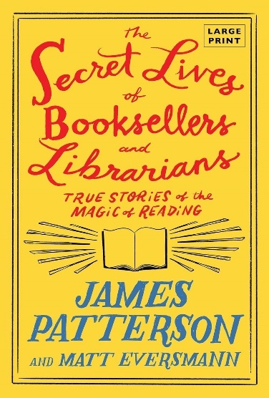

To be a bookseller or librarian…  
   
You have to play detective.   
   
Be a treasure hunter. A matchmaker. An advocate. A visionary. 

A person who creates “book joy” by pulling a book from a shelf, handing it to someone and saying, “You’ve got to read this. You’re going to love it.”  
   
Step inside *The Secret Lives of Booksellers and Librarians*and enter a world where you can feed your curiosities, discover new voices, find whatever you want or require. This place has the magic of rainbows and unicorns, but it's also a business. The book business.    
   
Meet the smart and talented people who live between the pages—and who can’t wait to help you find your next favorite book.

**December 9, 2024 – The Women by Kristin Hannah**

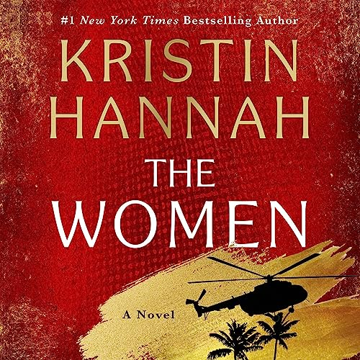*Women can be heroes.* When twenty-year-old nursing student Frances “Frankie” McGrath hears these words, it is a revelation. Raised in the sun-drenched, idyllic world of Southern California and sheltered by her conservative parents, she has always prided herself on doing the right thing. But in 1965, the world is changing, and she suddenly dares to imagine a different future for herself. When her brother ships out to serve in Vietnam, she joins the Army Nurse Corps and follows his path. As green and inexperienced as the men sent to Vietnam to fight, Frankie is overwhelmed by the chaos and destruction of war. Each day is a gamble of life and death, hope and betrayal; friendships run deep and can be shattered in an instant. In war, she meets—and becomes one of—the lucky, the brave, the broken, and the lost. But war is just the beginning for Frankie and her veteran friends. The real battle lies in coming home to a changed and divided America, to angry protesters, and to a country that wants to forget Vietnam.

*The Women*is the story of one woman gone to war, but it shines a light on all women who put themselves in harm’s way and whose sacrifice and commitment to their country has too often been forgotten. A novel about deep friendships and bold patriotism.